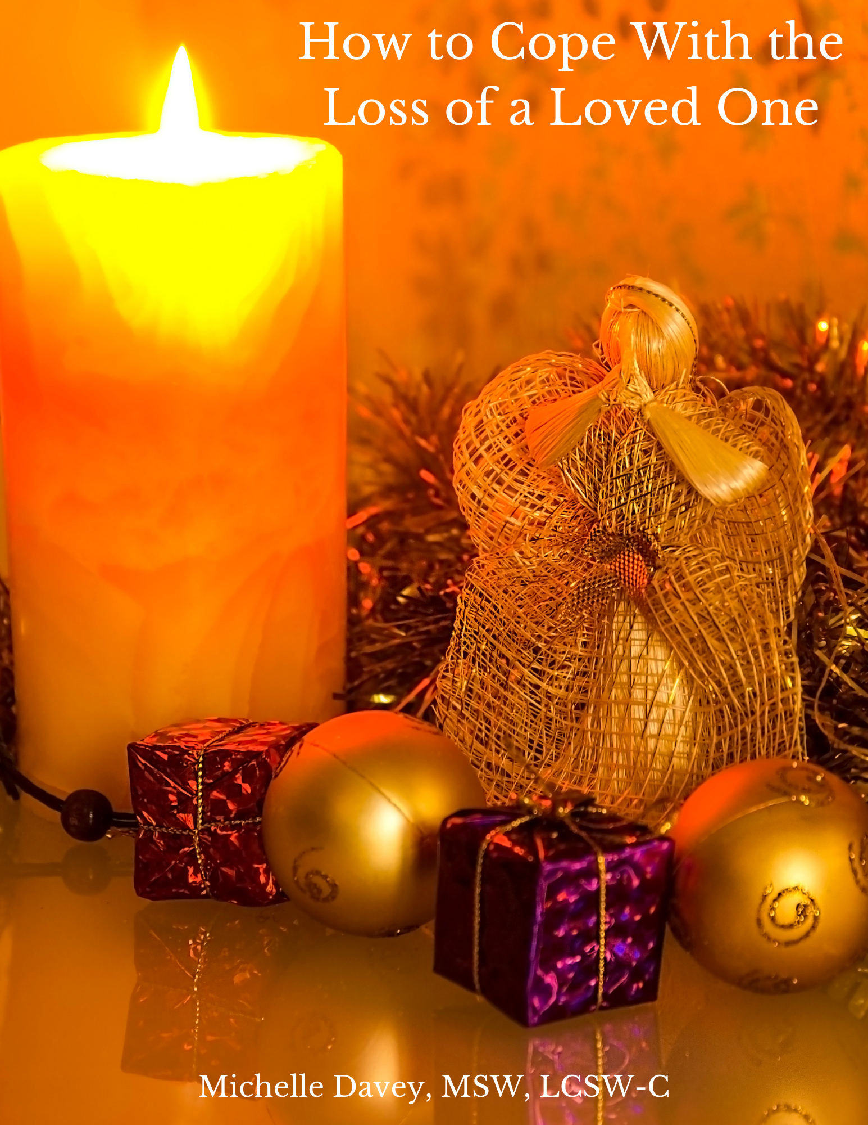

How to Cope With the Loss of a Loved One

If you live long enough, you’ll eventually have to deal with the death of a loved one. Everything that lives eventually dies, but just because death is natural doesn’t make it easier to navigate. But there is hope, as the bible tells us that blessed are those that mourn, for they shall be comforted (Matthew 5:4).
Below are some tips on how to cope with the loss of a loved one:

- There are no rules. Grieve in your way and at your own pace. Everyone is unique in how they deal with grief. Some people can move on quite quickly, while others languish in distress. Some people seek out the comfort of others, while some people choose to be alone.

- Experience your feelings. Rather than distract yourself from your emotions, experience your feelings. Just sit with them and explore them. Allow yourself to feel whatever you’re feeling. They won’t go away until you’ve allowed them to express themselves.

- Be patient. Grief can take time to run its course. How long does it take? It takes as long as it takes. There isn’t an established amount of time for the grief process. Everyone is different but expect that it will take some time.
- Allow others to help you. Many of us like to be “STRONG,” or we just don’t want to be a bother. But this might be a good time to accept some help. Allow your neighbor to run an errand for you, and let a friend or family member cook dinner. Focus on yourself and permit others to deal with the maintenance tasks of life for you.
- Get professional help if you need it. While some people manage to find their way through grief without professional help, others need help. There’s no shame in getting the help you require.

Visit the website below to find a therapist in your area:

- www.psychologytoday.com

Some of the ways you can honor your loved one:

- Share their stories/photos
- Keep something of them with you
- Donate to their favorite charity (in honor of them)
- Visit the gravesite (leave their favorite flowers)
- Create a memory box (a keepsake container that holds unique things)
- Write a letter/poem to your loved one
- Create a display at home dedicated to your loved one
- Create a unique personalized item such as a throw, pillow, or ornament.
Visit website: Personalization Mall

Watch video on how to deal with the loss of a loved one:
Click here for the video or go to: https://www.youtube.com/watch?v=Jl7axuIeVxI&t=2s
Michelle Davey, MSW, LCSW-C
Founder of Our Wings of Hope, LLC

